
University of Balamand
Faculty of Engineering
Department of Computer Engineering
Spring 2024-2025

Bitonic Sorter – System Verilog

CPEN313: Computer Embedded and Systems

Prepared by: Lana El Chaar A2210670
Nicolas Darwish A2210074
Priyan Wijeratne A2120283

Presented to: Dr. Rafic Ayoub

Submitted on: 25th of May 2025
Table of Contents
1. Introduction 2
2. Objectives 3
3.Design Methodology 3
4. Procedure 4
5. Results 4
6. Discussion 4
7.Conclusion 4

Introduction
In data processing, sorting algorithms are essential for putting items in a particular order. Although the performance of traditional algorithms such as Bubble Sort, Insertion Sort, and Quick Sort varies, many of them are sequential in nature and not the best candidates for hardware implementation. On the other hand, Bitonic Sort's predictable, structured comparison and merging patterns make it ideal for parallel hardware designs. The goal of this project is to use System Verilog's Bitonic sorting algorithm to develop and implement a parallel sorting system. The objective is to develop an adaptable sorter that can effectively handle input sizes of 8, 16, or 32 elements. Intel Quartus Prime software will be used for simulation in order to validate the design. The hardware-friendly design made possible by Bitonic Sort's deterministic nature makes it perfect for FPGA implementation.

Objective
This project's goal is to use SystemVerilog's Bitonic sorting algorithm to develop and implement a parallel sorting system. The system uses the structural parallelism that comes with the Bitonic sort to efficiently sort a configurable number of items, like 8, 16, or 32. In order to confirm accuracy and evaluate hardware performance, this project aims to simulate and implement on the Intel Quartus Prime platform. Creating a version that performs the comparison operations serially while maintaining parallelism in the sorting process as a whole is an optional improvement that enables a comparison of the two implementations' resource usage and performance.

Design Methodology

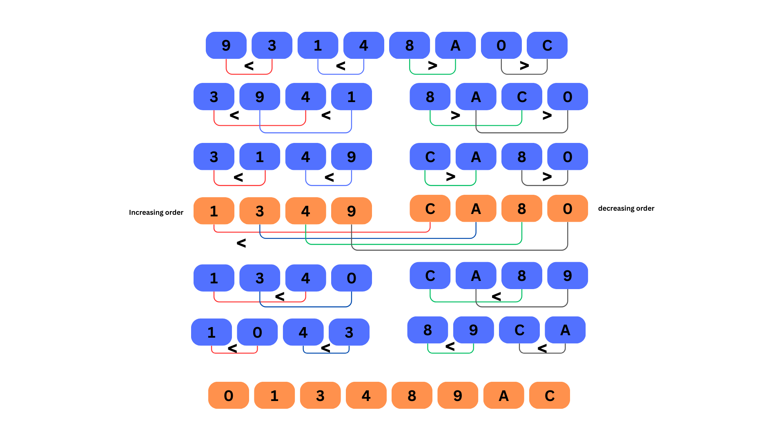

Figure 1: Bitonic Sort Algorithm for 8-Bits

8 Elements Bitonic Sorter System Verilog Code
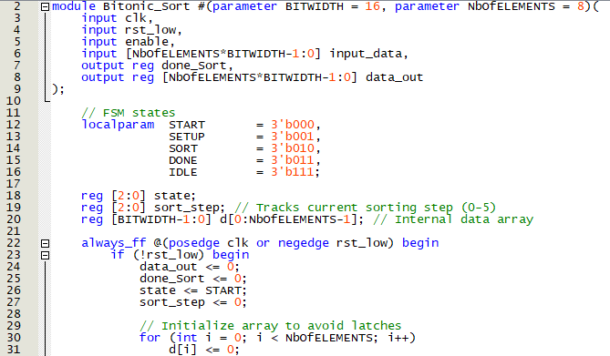

We start by the module definition, it’s a parameterized code with 8 elements 16 bit each, inputs are clk, rst_low, enable, input_data bus and the main 2 outputs are data_out bus and done_Sort.
FSM states were settled up START, SETUP, SORT, DONE and IDLE. Nevertheless, state points to the current FSM state, sort_step goes for which phase of sorting is being executed and d is the internal array that stores the elements to be sorted.
The always_ff block handles both reset and clock- triggered behavior, when rst is active low the state will go back to START and the inputs will be set to zeros as well as outputs.

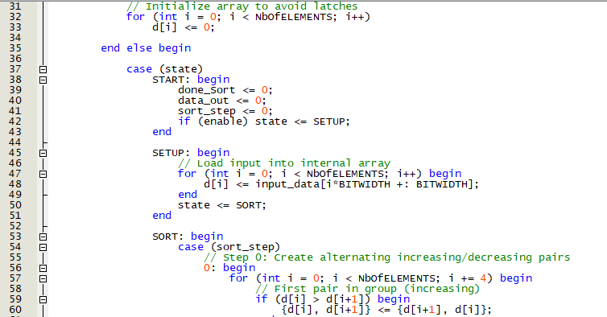

Case START: as long as enable is not 1 it will stay in the same state with 0 output and no step ahead.
Case SETUP: data will be loaded into temporary registers “d “. Once it’s finished we will jump to the main state “SORT”
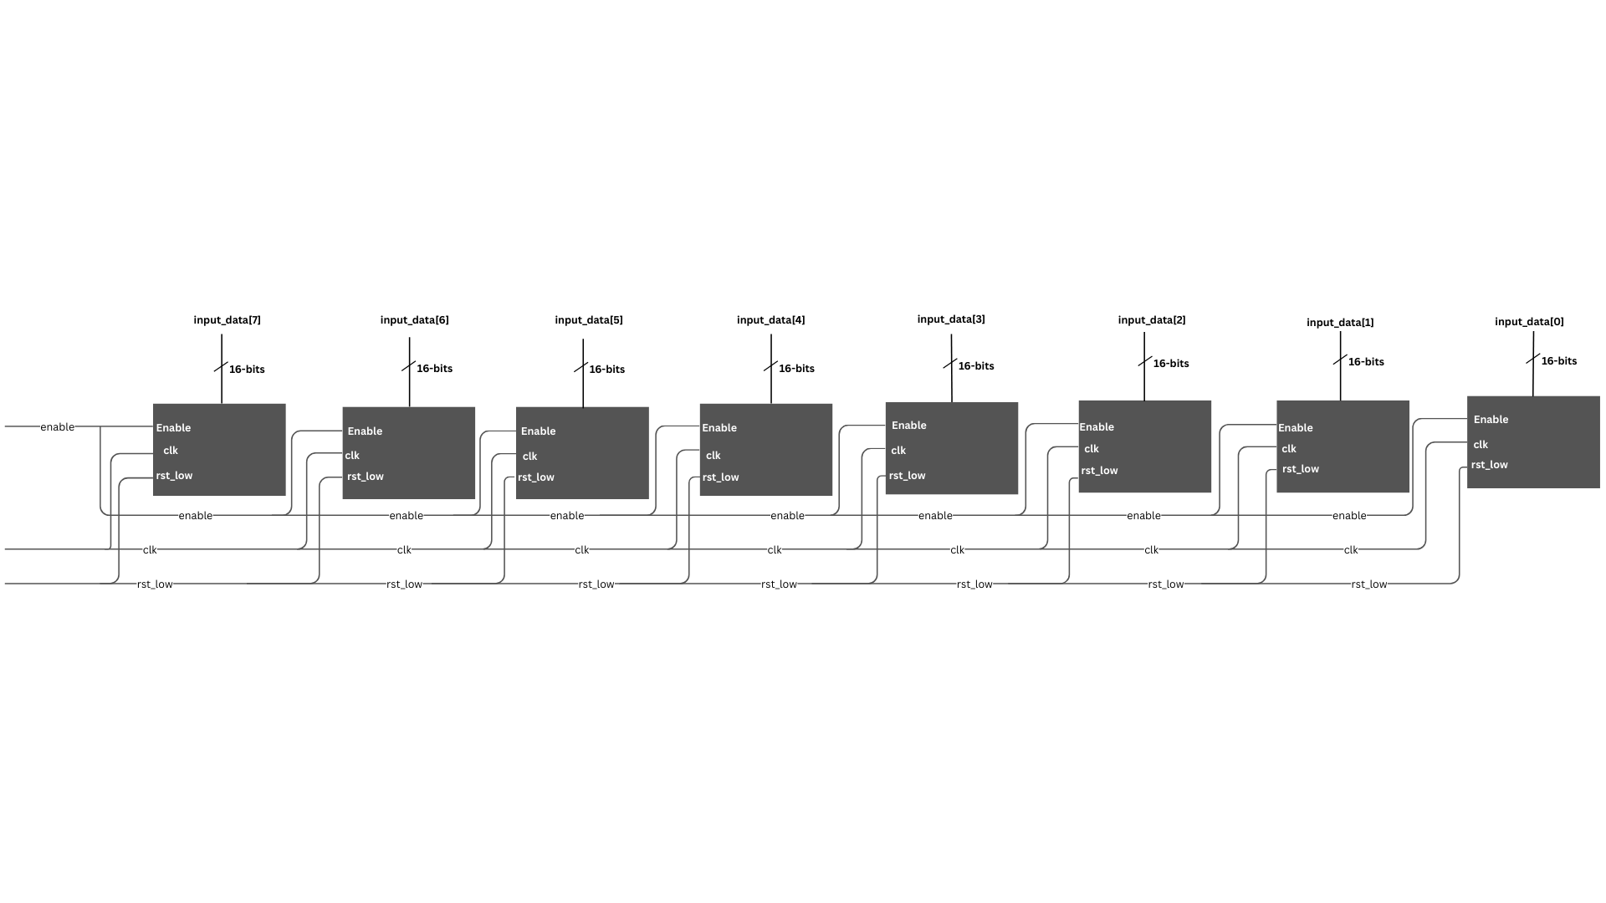

Figure 2: Loaded data into temporary registers
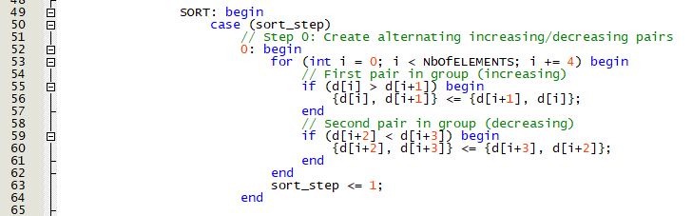

The SORTING state has also a state machine to divide tasks properly. This piece of code will handle the comparison between elements for the first step. To be more clear, first 2 elements will enter a less then comparator with intention to be in an increasing order, a[2] and a[3] will enter into the same comparator with intentions to be in decreasing order.
Less_out

a[1], a[0]
Less_out
< (16-bits)
a[0]

y [ 32 bits]
0
a[0], a[1]
1
a[1]

Less_out

a[2], a[3]
Less_out
< (16-bits)
a[2]

y [ 32 bits]
0
a[3], a[2]
1
a[3]

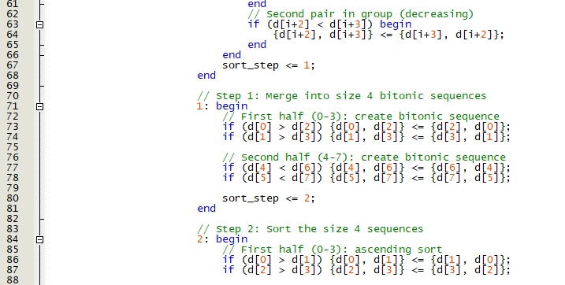
After finishing the process, sort_step will enter into the second one.

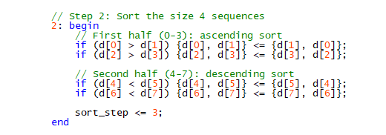
In this sort step we will merge the first 4 elements in increasing order and the last 4 elements is decreasing order. To do this, a[0] and a[3] will be compared in increasing order as well as a[2] with a[4], as for the last 4 elements we will compare a[4] with a[6] and a[5] with a[7] in decreasing order

This step is to sort all first 4 element in decreasing order a[0] with a[1] and a[2] with a[4]. Decreasing order will be specified for the last 4 elements a[4] with a[5] and a[6] with a[7].
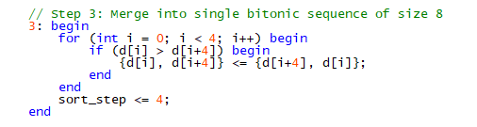
Now we will sort the whole bitonic sequence into 1 sequence with an increasing order. To do so, we will compare a[0] with a[4], a[1] with a[5], a[2] with a[6] and a[4] with a[7].

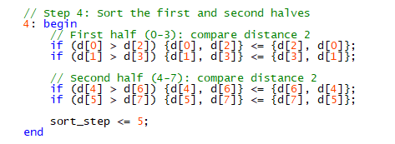
This step handles the comparison in increasing order between the elements with steps ahead which means: a[0] with a[2], a[1] with a[3], a[4] with a[6] and a[5] with a[7].
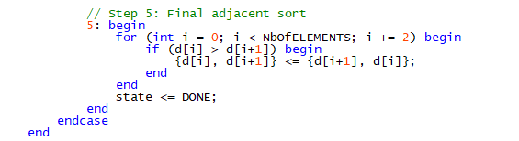
Final step is to check the increasing order of elements with 1 step ahead: a[0] with a[1], a[2] with a[3], a[4] with a[5] and a[6] with a[7].
Thus we will have a completely sorted array with an increasing order.
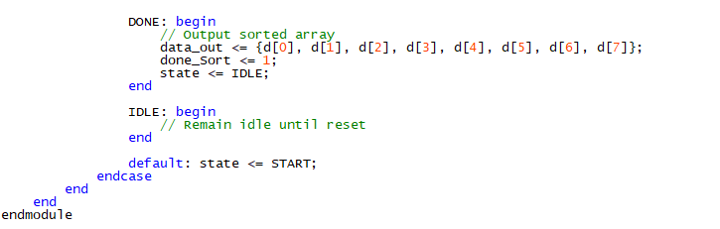
The data will be loaded from temporary registers “d” into data_out bus. The state will go back to IDLE where it waits the reset low to enter again the START state.

Results of 8 elements Bitonic Sorter
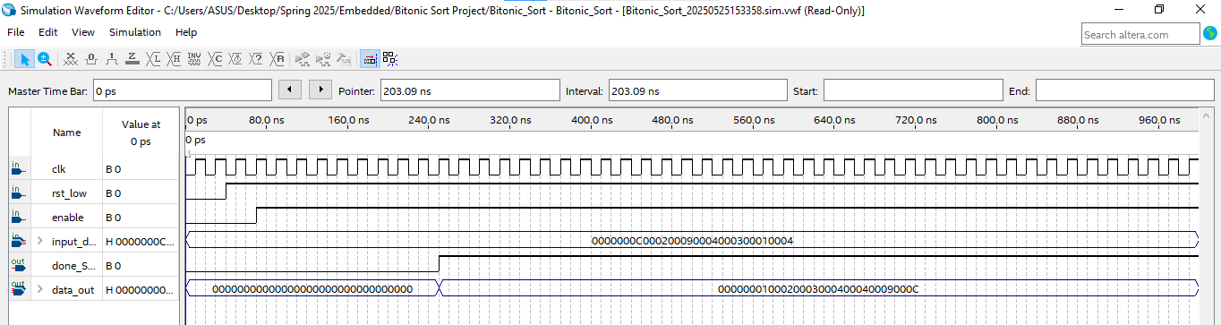
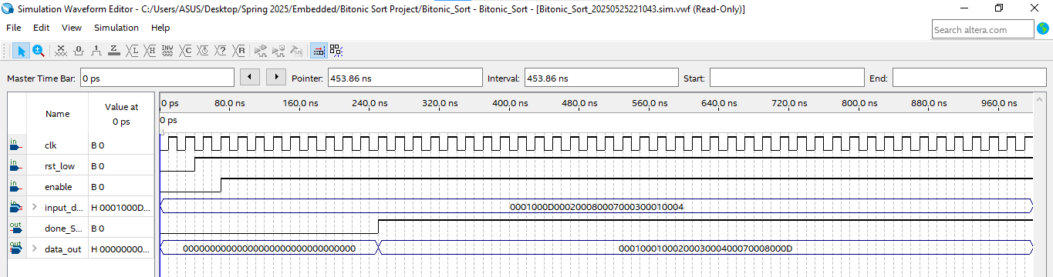
These two sample shows how the code perfectly works for the bitonic sort, we can see in the two examples that the arrays were sorted with an increasing order with data_Sorted = 1 which means the process is done.

Discussion
The Bitonic sorter we implemented was able to handle sorting for a set of 8 elements using a fully deterministic approach. Two key scenarios were tested during simulation: Sorting 8 random elements and sorting repeated elements.
In the random 8 elements case, we gave the sorter 8 completely different numbers, just to see if it could handle a general case with no patterns or repetitions.
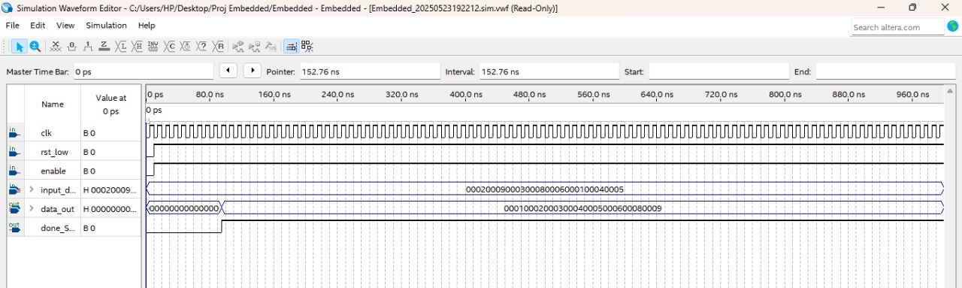
The results came out exactly as expected, the values were sorted in perfect ascending order. This showed that the sorting logic, including the comparison and swapping stages, was working just as intended.
Then, we tested a more realistic scenario: what if some numbers were repeated in the input? For example, we tried values like:
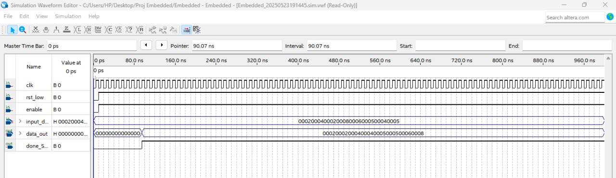
The sorter handled it just fine and gave us a correct sorted result: {2, 2, 4, 4, 5, 5, 6, 58}. Even though some numbers were identical, the sorter didn’t break or behave oddly. This confirmed that our design can sort also cases where some values appear multiple times.
The merge step is one of the more challenging parts of bitonic sorting, particularly when it comes to hardware. In our case, we were able to avoid complicated dynamic logic by hardcoding the entire bitonic sorting sequence for eight elements, which allowed the merge step to proceed smoothly and sort everything as intended. The waveform shows the progression from semi-sorted to fully sorted at the end.
In Quartus, the design ran without any problems. We didn’t encounter weird glitches, race conditions, or incorrect values. The done_Sort signal was triggered exactly when the sorting finished, which gave us a clean indicator of when the output was ready. That makes this design easy to integrate with other modules or future improvements.
While this setup works great for 8 elements, scaling up to 16 or 32 will need more complex logic. When we tried that earlier, we ran into issues where only half the elements were getting sorted properly — most likely because the merge phase wasn’t fully covering all the data. To make it work for larger input sizes, we’d need to either repeat the merging stages more intelligently or make the sorting structure dynamically adapt to the size. That’s something we could improve in future versions.

Conclusion
In this project, we used SystemVerilog to design and develop a bitonic sorter that can process eight or sixteen input components. Intel Quartus Prime was used to test the design, and the simulation results demonstrated that the sorting functioned properly in every test case. It took a lot of meticulous planning to translate the intricate algorithm known as bitonic sort—which has numerous comparison and swap stages—into hardware logic. There were further difficulties when the sorter was made adjustable for varying input sizes.
We gained a lot of knowledge about parallel sorting algorithms and their hardware implementation in spite of the challenges. Through this project, we learned how to create effective, modular designs and gained useful expertise with SystemVerilog and FPGA simulation.

